**SQL 201 ASSIGNMENT**

1**)** For different category of acquirers, what is the average number of months since the inception of the acquired company after which they are acquired.

SELECT

acquisitions.acquirer_category_code,

round(

AVG(

(

cast(acquisitions.acquired_at_cleaned AS date) - cast(companies.founded_at_clean AS date)

) / 30

)

)

FROM

tutorial.crunchbase_companies_clean_date AS companies

LEFT JOIN tutorial.crunchbase_acquisitions_clean_date AS acquisitions ON companies.permalink = acquisitions.company_permalink

GROUP BY

acquisitions.acquirer_category_code

ORDER BY

acquisitions.acquirer_category_code;

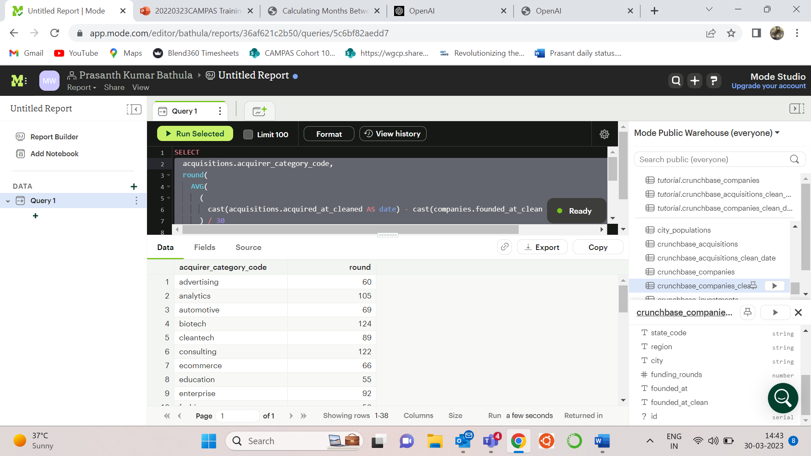

2)Which investor (company ) is more likely to invest in USA based companies?​

1. SELECT

investor_name,count(distinct company_name) as no_of_investments

FROM

tutorial.crunchbase_investments

WHERE

company_country_code = 'USA'

GROUP BY

investor_name

ORDER BY

no_of_investments DESC

LIMIT 1;

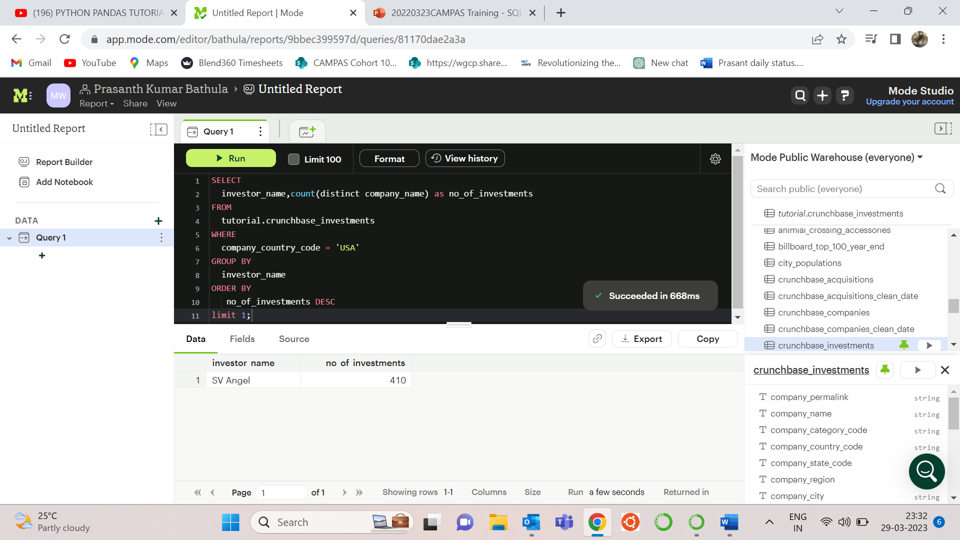

2) **Out  of all 'operating' status companies, which category of companies have the highest average funding_total_usd?**

SELECT

category_code,

avg(funding_total_usd) AS avg_funding_total_usd

FROM

tutorial.crunchbase_companies

WHERE

STATUS = 'operating'

GROUP BY

category_code

ORDER BY

avg_funding_total_usd DESC

LIMIT

1;

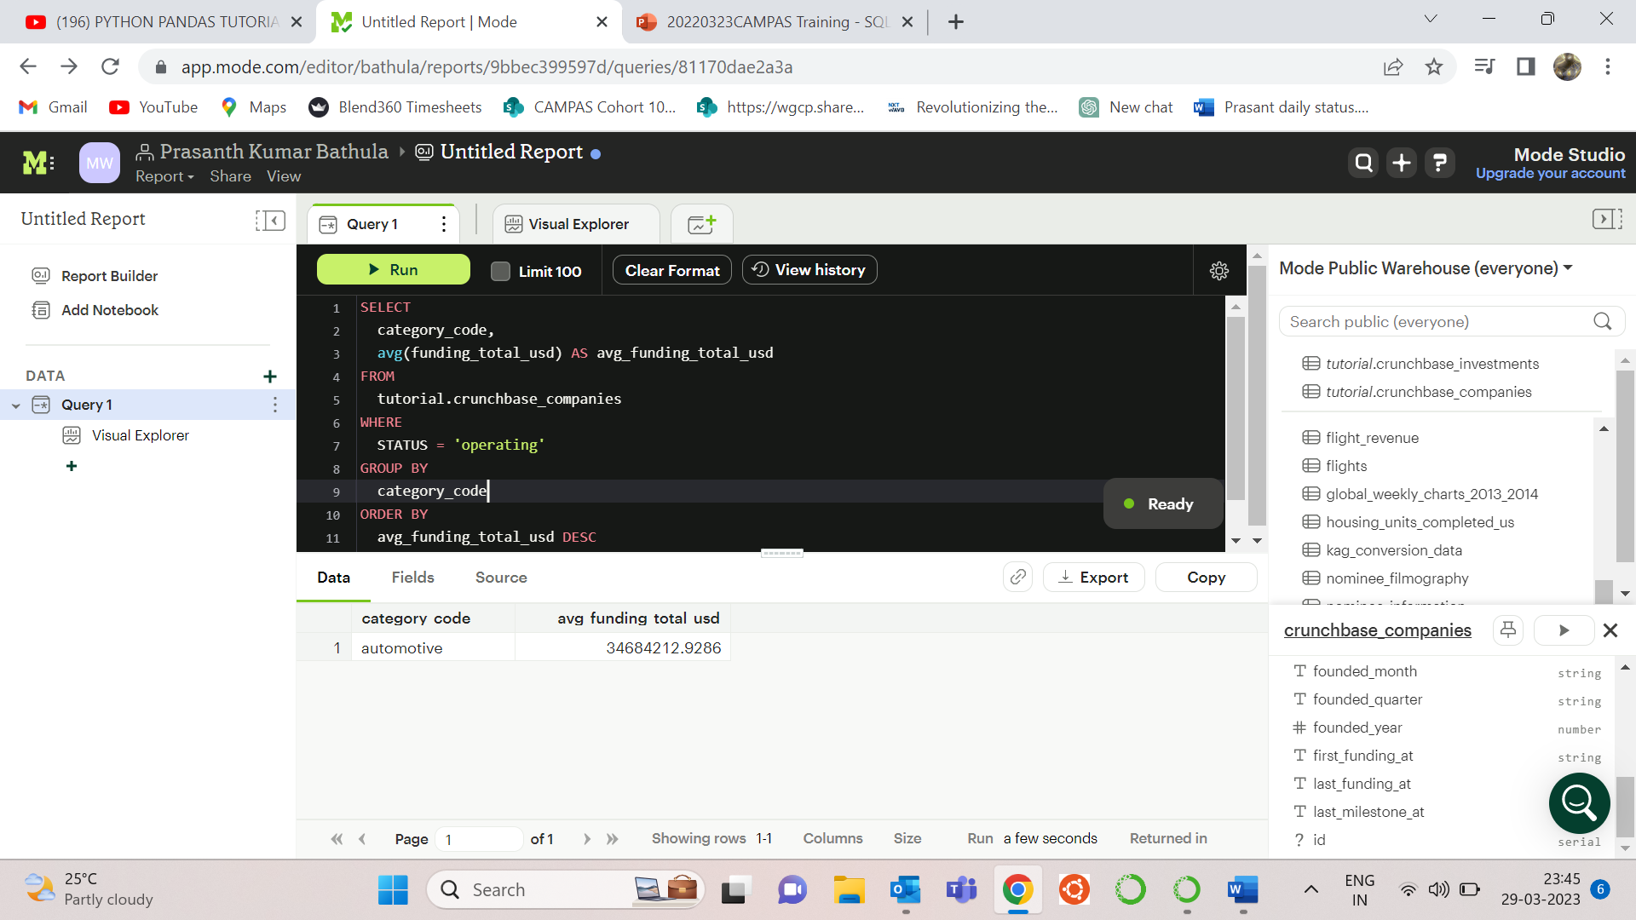

1. Is there any trend for quarters when more companies are acquired ​?

A) SELECT

substring(acquired_quarter, 6, 7) AS quarter,

count(*) AS no_acquisitions

FROM

tutorial.crunchbase_acquisitions

GROUP BY

quarter

ORDER BY

no_acquisitions DESC;

